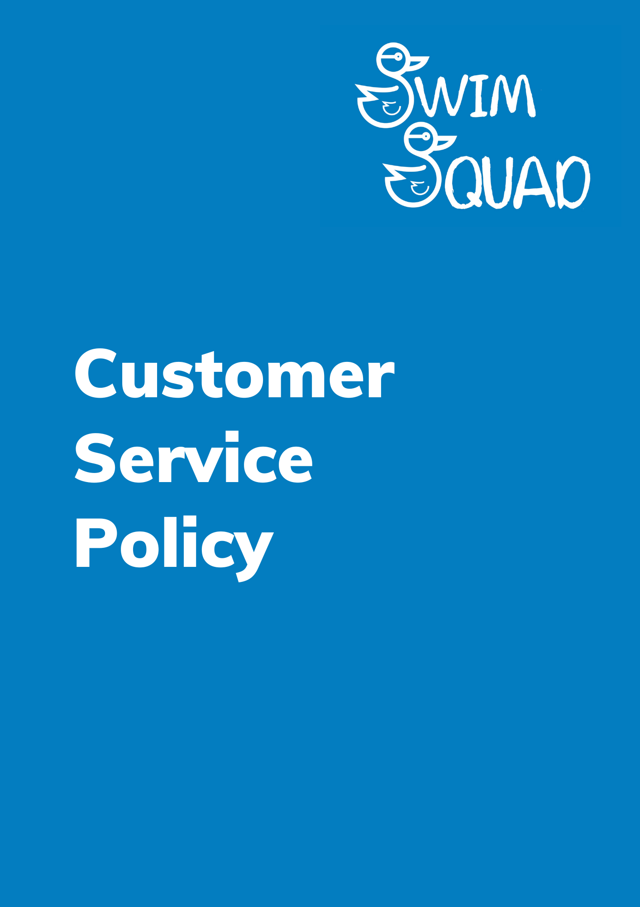
Purpose
Swim Squad is dedicated to delivering an efficient, responsive, and supportive customer service experience. Our aim is not only to meet, but to exceed customer expectations whenever possible.
We believe in a consultative and collaborative approach, actively engaging with employers, industry bodies, and customers to uphold the highest standards across all aspects of our operations.
Our commitment to excellence is evident through our ongoing efforts to maintain quality assurance standards that align with regulatory requirements. While we strive to consistently provide a superior level of service, we acknowledge that there may be occasions when we fall short of both your expectations and ours. In such instances, we encourage you to promptly share your concerns with us. We are committed to addressing your concerns positively and rectifying any mistakes that may have occurred.
For detailed information on our procedures for handling complaints, please refer to our Complaints Policy, which is available on our website. If you prefer, you can also request a copy by reaching out to us directly. Your feedback is valuable, and we are here to ensure your satisfaction with Swim Squad's services.
Policy
Swim Squad aims to:
- We will provide services which meet the needs of our customers.
- We are committed to continual improvement, identifying, and sharing good practices.
- We are committed to listen and respond positively to all customers.
- We are committed to delivering reliable information.
- We will provide a courteous and accurate response to all customer enquiries, including those with specific areas of expertise and for customers to feel they have had a positive experience, receiving the answers/information they requested.
- We aim to ensure all our services are delivered efficiently and are of the highest standards.
Customer Enquiries

Our goal is to provide a personalised service to our customers every time you reach out to us with an inquiry. When you engage with one of our team, their primary objective is to efficiently address your query on the first attempt. However, if the situation requires additional research or information, the team member will take full responsibility for ensuring they obtain the accurate details you need. In such instances, you can expect the team member to keep you regularly updated on the progress of your request.

If you contact us via email, we aim to respond to your enquiry within 7 working days.

Zero Tolerance

We are committed to treating all customers fairly and consistently, even in cases where their actions may be deemed unacceptable. We firmly believe that every customer has the fundamental right to be listened to, comprehended, and treated with respect. Our objective is to offer an inclusive and accessible service to all individuals, and we are dedicated to making every possible endeavour to meet the unique needs of our customers.

This policy details how we are committed to treating our customers in a fair and positive way whilst managing actions that may result in unreasonable demands on our services or on our staff. The unacceptable behaviour of customers can sometimes make it difficult for us to deal with the issue or complaint in question.

This policy is required to address a very limited number of cases where actions become unacceptable which could lead to abuse of our staff, may cause a delay in fulfilling other tasks and prevent us from providing a service to other customers.

The primary purpose of this policy is to outline our approach to handling instances of unacceptable behaviour. By doing so, we aim to safeguard the well-being of our staff and maintain our commitment to delivering a high-quality service to all our customers.

We will not tolerate any form of unacceptable behaviour during any form of contact, this could be as follows:
- Face to face contact
- During a telephone conversation
- Contact via email or live chat on our website.

Unacceptable behaviour can be as follows:
- Aggressive or abusive behaviour
- Unreasonable demands
- Unreasonable levels of contact
- Unreasonable use of the complaints process.

We will take the following actions when appropriate:
If a customer becomes aggressive or physically violent towards staff, we will report this matter to the police and will cease all communications with that person.
When a customer behaves in an unacceptable manner towards a member of staff, a warning will be issued by email explaining that their behaviour is unacceptable and will not be tolerated, our records will be updated accordingly.
If the unacceptable behaviour continues after a warning has been issued by us, a suspension will be put in place.

Monitoring and Review
We will conduct regular reviews of this policy and its associated procedures as an integral part of our commitment to quality assurance. These periodic assessments are designed to ensure that the policy remains effective, aligns with our service offerings to customers, and remains pertinent to the diverse needs of individuals. By doing so, we aim to keep the policy up to date, ensuring that it continues to serve its intended purpose effectively.
The next date for review will be September 2024.

